**Launch and Connect to an EC2 Linux Instance.**

* **Launching an EC2 instance**
* Go to Amazon dashboard
* Select EC2

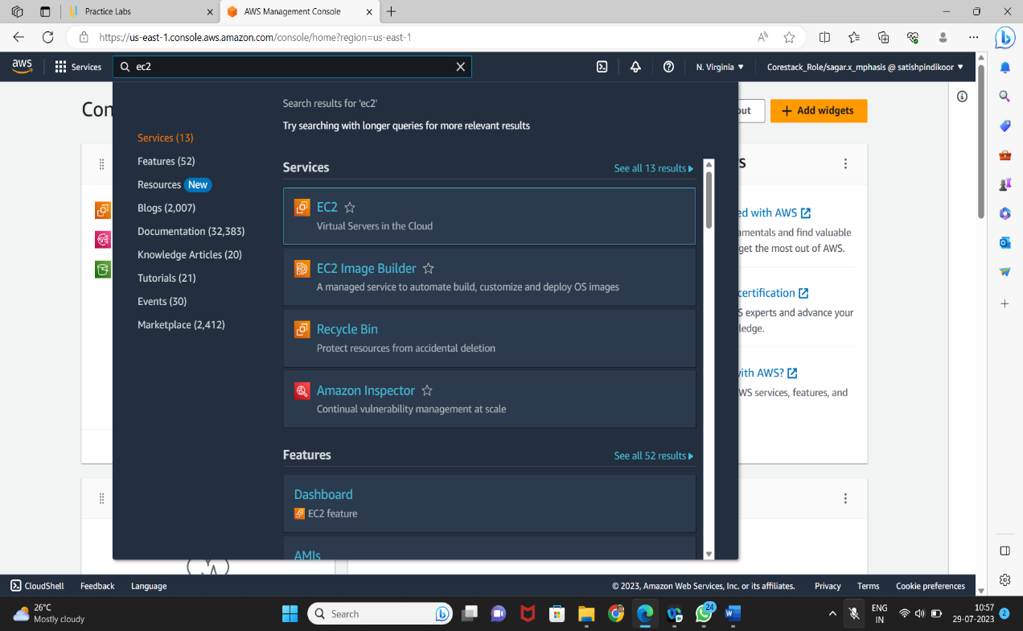

* Click on *launch instance* to run any instance

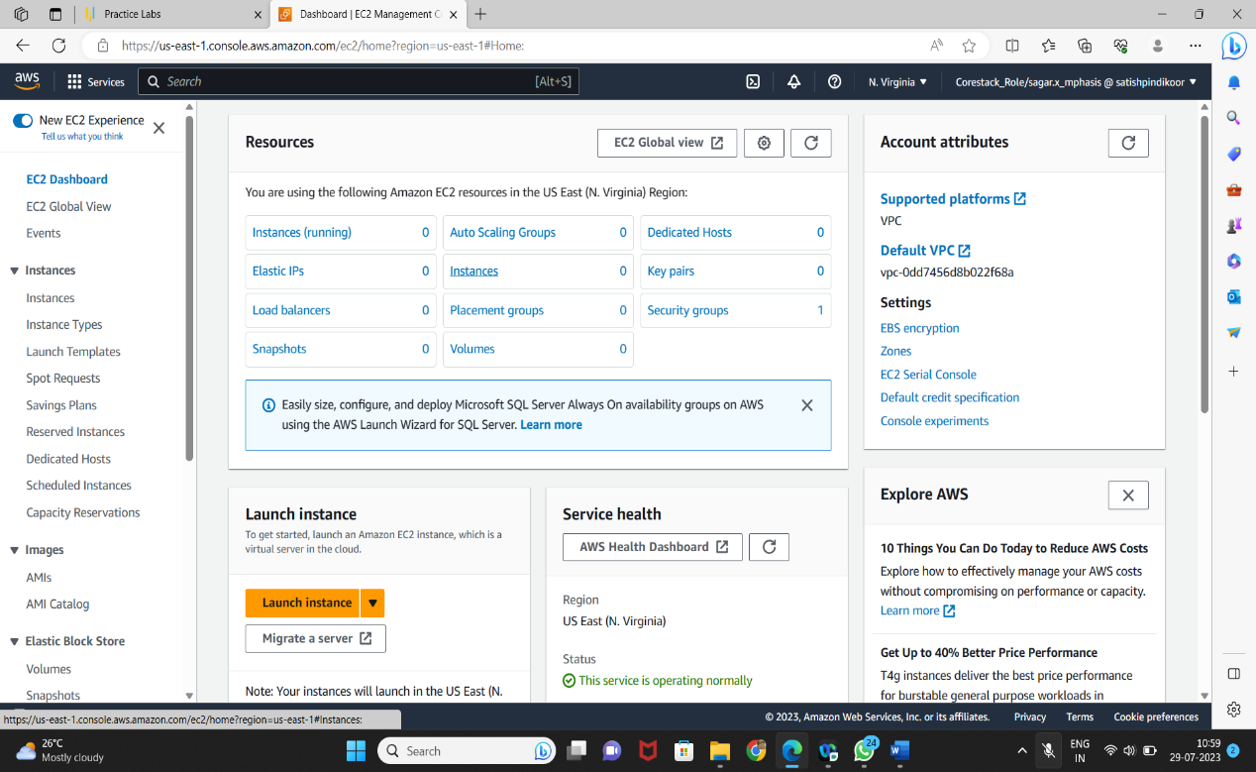

* Give Name in Name and tags

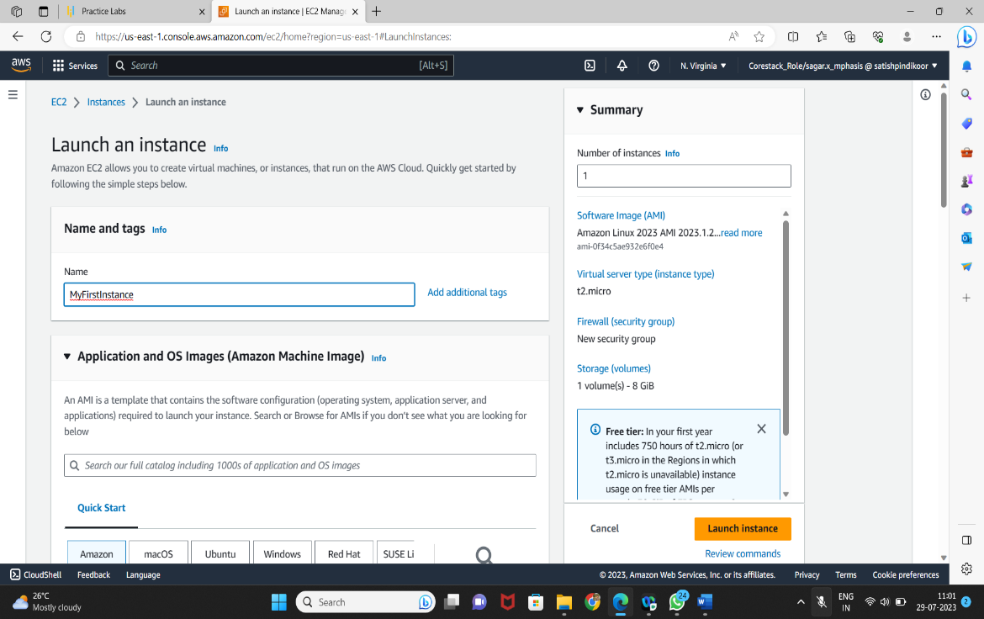

* Select the AMI

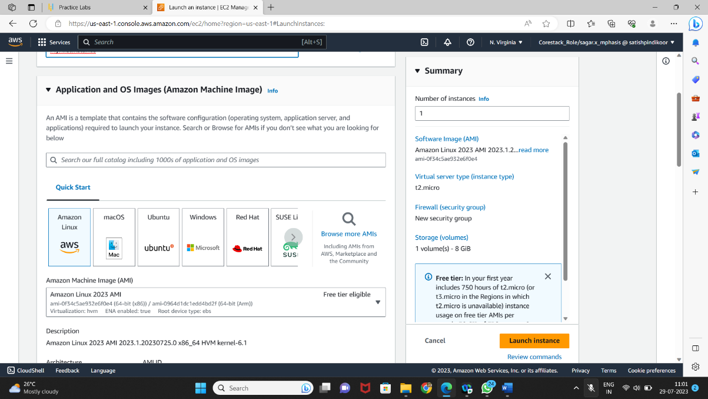

* Select t2.micro as the instance type

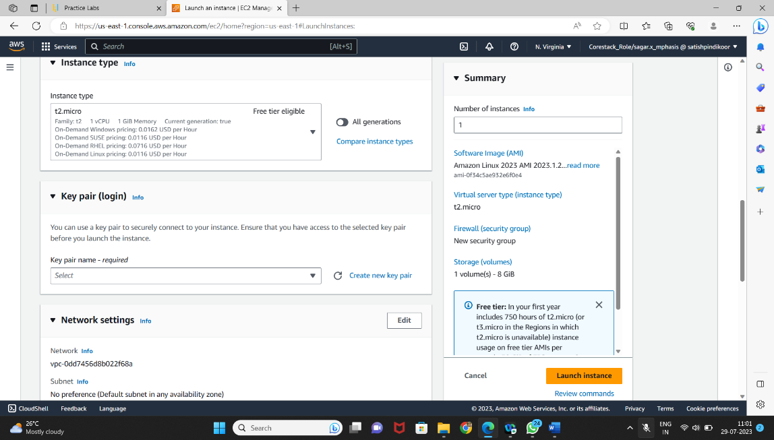

* + You can add a key-value pair to the instance

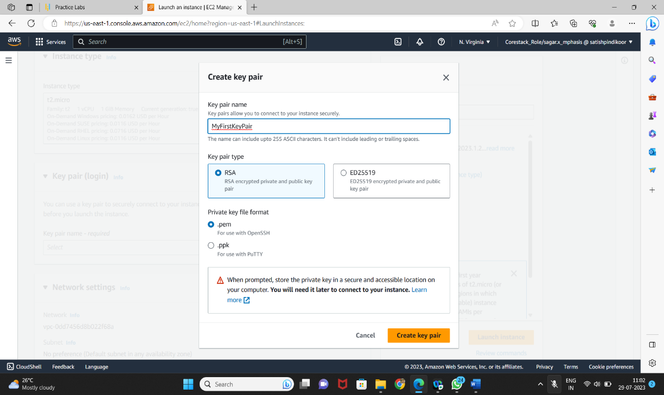

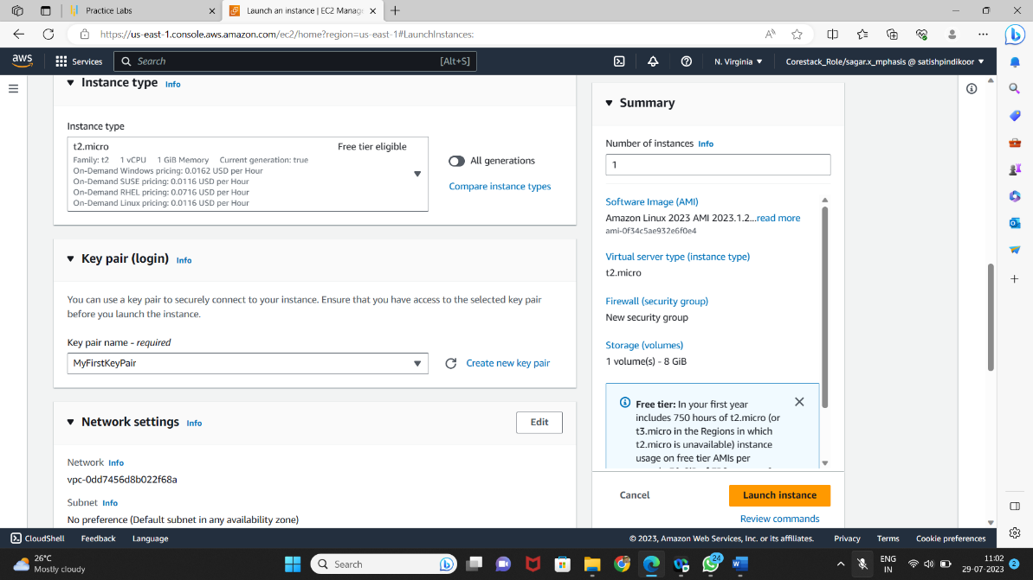

* + Network Settings

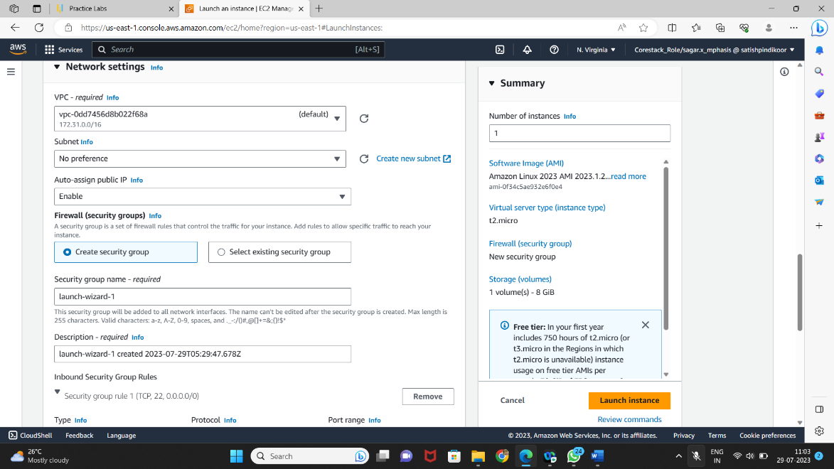

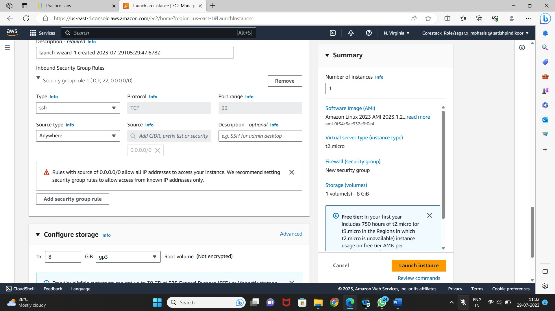

* + Attach the three policy groups depending on the type of access required

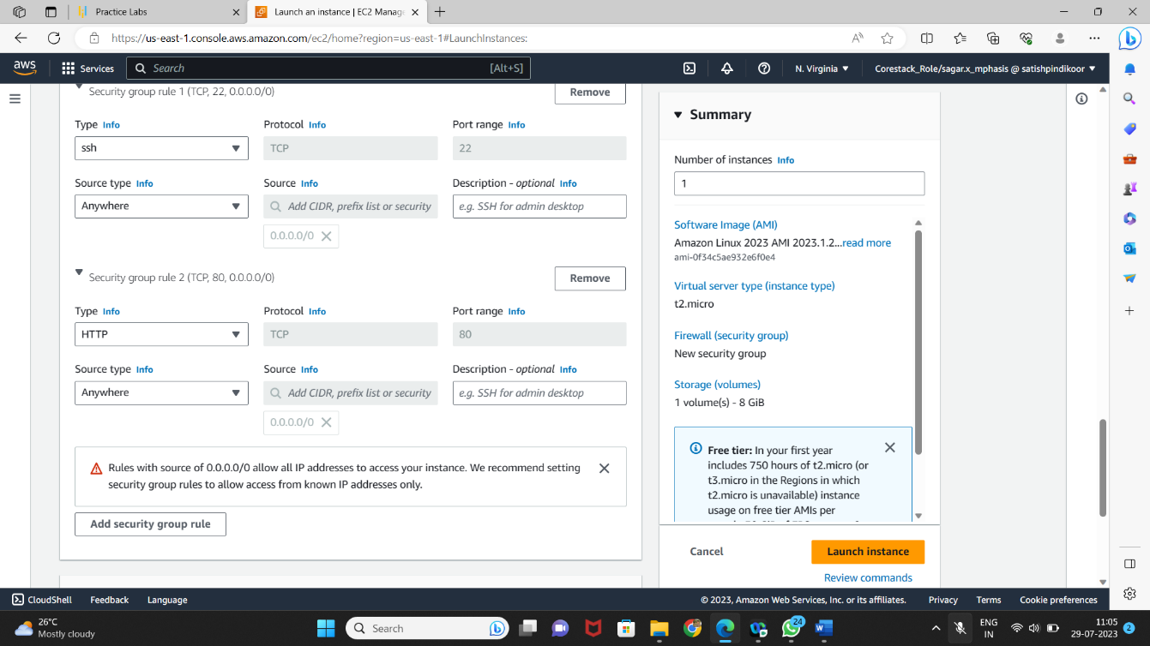

* + The instance is ready to use

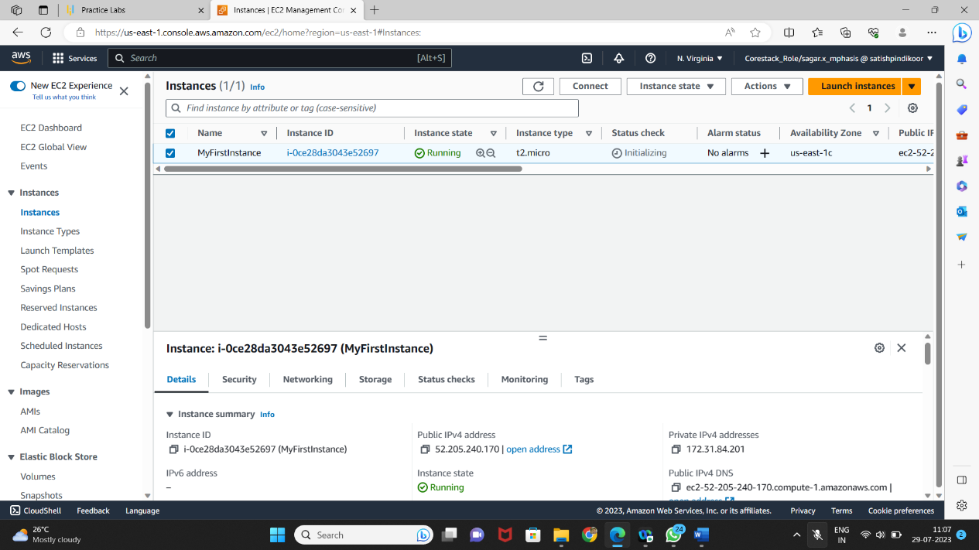

* + Click on *Connect* on EC2 dashboard
  + Run the ssh command provided

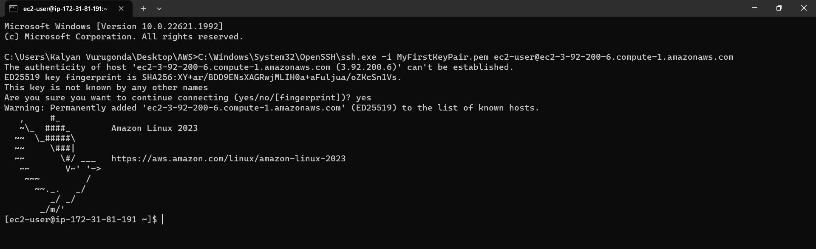

* **Connecting to an EC2 instance**
* Run the following command to launch a website over EC2:
* *yum install httpd -y*

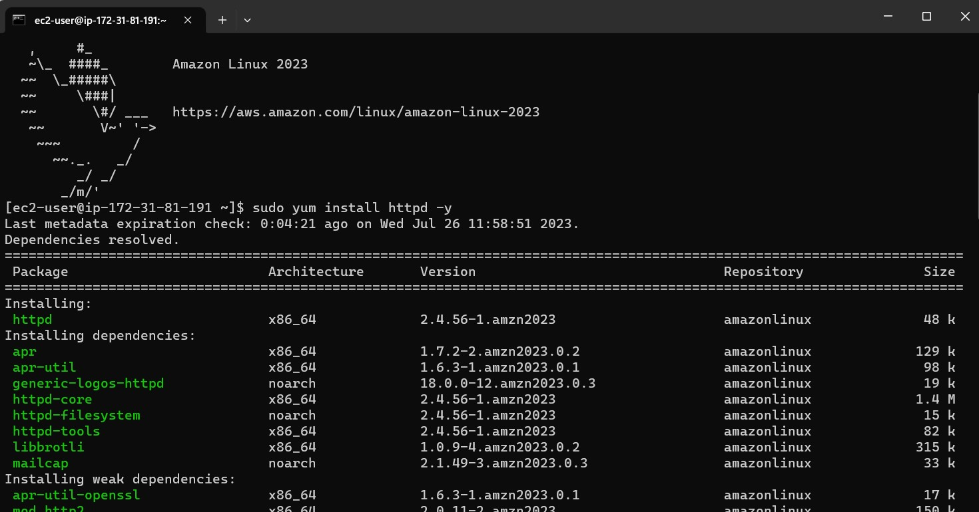

* Navigate to /var/www/html and create index.html file using command *vi index.html*

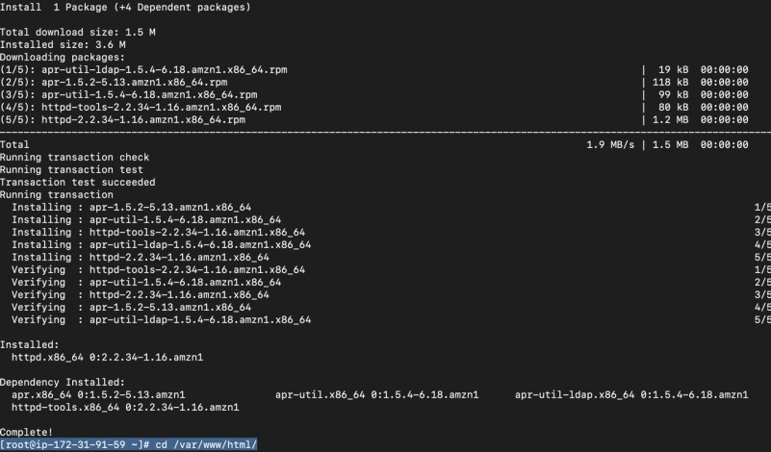

* Enter *I* and start creating HTML file content
* Once done, type *:wq!*

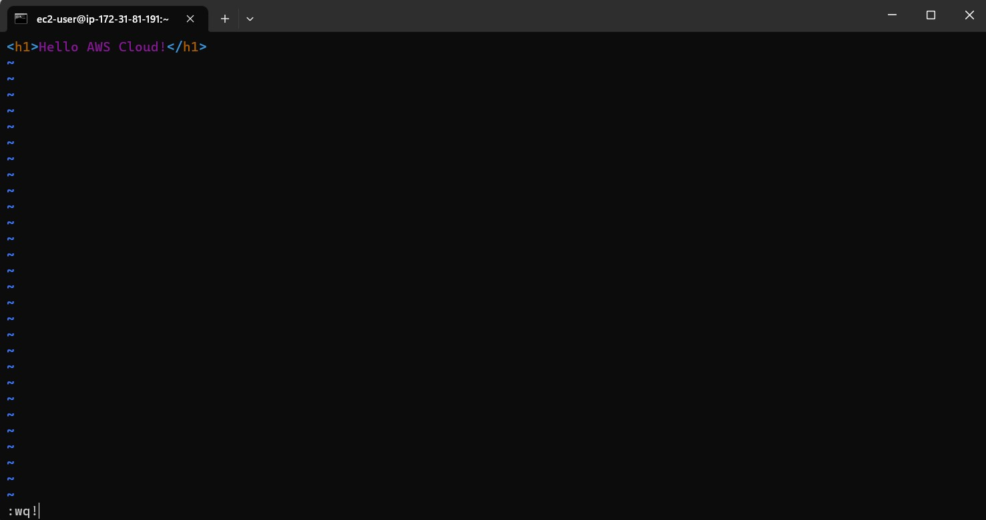

* Using public IP of EC2 instance, you can see your app running on the browser



